

**ADAMA SCIENCE AND TECHNOLOGY UNIVERSITY**

**SCHOOL OF ELECTRICAL ENGINEERING AND COMPUETING**

**DEPARTMENET OF COMPUTER SCIENCE AND ENGINEERING**

**SENIOR PROJECT DOCUMENTATION**

**PROJECT TITLE: EVENT COORDINATING PLATFORM WITH PAYMENT MODALITY**

**Group members**

**Name ID Number**

1. **Helen Abay A/UR5176/09**
2. **Samiya Sultan A/UR4958/09**
3. **Tsion Belachew A/UR4955/09**
4. **Tsion Merid A/UR4884/09**
5. **Yerosan Birhanu A/UR4254/09**

**ADVISOR**

[AYENEW YIFRU]

**COORDINATOR**

[ABUBEKER YIMAM]

Submission date:-11/04/2021 GC

Table of Contents

1.2 Background of the existing system 6

1.3 Statement of problem 7

1.4 Objectives of the project 7

1.4.1 General objective 7

1.4.2 Specific objective 7

1.5 Scope and limitation 8

1.5.1 Scope 8

1.5.2 Limitation 9

1.6 Feasibility study 9

1.6.2 Technical feasibility 9

1.6.3 Economical feasibility 10

1.7 Feature of the project 10

1.8 Significance of the project 10

1.9 Beneficiaries of the project 11

1.10 Methodology 12

1.10.1 Observation (using checklist tool) 12

1.10.2 Interview (focus groups) 12

1.10.3 Existing data 12

1.10.4 System Development Methodologies 12

1.11 Development tools 12

1.12 Required Resources with Cost 13

1.13 Duration and plan of action (Gantt chart) 13

1.14 Team Composition 14

CHAPTER 2 14

2. Description of existing system 14

2.1 Overview 14

2.2 Description of existing system 15

2.3 Major Function of the Current System 15

2.3.1 The manual event management system 16

2.3.2 The event management software 16

2.4 Users of current system 18

2.5 Drawbacks of existing system 19

2.5.1 Manual event organizing system 19

2.5.2 Event management spread sheet 19

2.5.3 Event management software’s 19

2.5.4 Virtual event management system 19

Chapter 3 20

3. Proposed System 20

3.1 Overview 20

3.2 Functional requirements 20

3.3 Nonfunctional requirements 21

3.4 Scenarios 22

3.5 Use Case model 23

3.6 Object model 31

3.7 Dynamic model 33

3.7.1 Sequence diagram 33

Diagram 3.7.2 sequence diagram of booking 35

3.7.2 Activity diagram 38

3.7.3 State chart diagram 42

Chapter 4 46

4.1. Overview of system design 46

4.3 System process 47

4.4 Subsystem decomposition 48

4.5 Hardware/software mapping 50

4.6 Persistent data management 51

4.7 Components diagram 54

4.8 Database design 55

4.9 Access Control 55

4.10 User interface 57

Chapter 5 59

5.1. Overview 59

5.2. Coding standard 59

5.3. Prototype Setup 61

5.4. Implementation Detail 62

5.5. Deployment 63

Chapter one

1.1 Introduction

An event is celebration or display of some team to public audience for limited time on specified location. There are many type of event including art exhibition, music concert, panel discussion, cultural celebration, educational seminars, festivals and conferences. Peoples which create the events are called event organizers and those who attend the event are attendees. Event owners are people or organization which communicate with event organizers and create their event. Events create positive social cultural impact among the society. In the preparation of event, event owner’s request, organizers have to plan, coordinate and execute events in order to guarantee the satisfaction of their customer expected to attend the event.

Event owners think of certain events and communicate with organizers. They check the schedule and sign agreement Event organizers are responsible of organizing an event which needs registrations of hundreds of attendees, bookings, schedules, ticketing, and more. Managing many events at a time was really difficult and inefficient. Event owners and event organizers communicate by visiting their office which is time taking. Event organizers had to use lots of separate tools: spreadsheets, email services, website builders, and a lot of paper. These approach results forgetting to track changes, too many guests, forgetting attendee engagement and Communication with attendees and among team members would be quite chaotic.

Event coordinating platform is web based business application that enhances project management to the creation and development of large scale events. It is a platform for management practice in creation and development of festival events, meeting, seminars and conferences. Event coordinating platform is used by different event organizers as a means of advertising their events and attendees use to view event lists in the country with their venue and time to book according to their interest using the booking system provided. Event organizers create event by providing details of the event such as when and where the event takes place, duration of the event, categories of the event, numbers of the attendees, and the payment procedure by using the platform.

This platform allows users to select affordable event from the list of event types. All this data is locked in the database. The system efficiently store maintains and retrieve data from its database and can use it for further analysis. It provides latest notification and updated information to its user

# 1.2 Background of the existing system

The event planning system available provides services only during the working days meaning that customers have limited time to make reservations for particular services. The customers take their time to travel to the event management offices to book for the event and even going to the bank and pay the money. There is a lot of paper work pertaining the events scheduled and those pending schedules, they also use phone calls. Event Planners uses a paper based file system, process and monitor event bookings data, financial data and personnel data. Information about the amount of money collected on a given event is recorded using pens and paper. Branch managers are always required to produce a report of the progress and success of the events handled. This requires a financial analysis which is always complicated sincere all transactions are manually done at the offices. In order for the customers to place and confirm bookings, they must visit to the company branch office. A booking is confirmed by a cash payment to the office. On receiving the money, a cashier issues a receipt containing the details of the event which include the event name, number of visitors expected, amount paid and the event date.

Weaknesses of the Current Systems are the use of a paper-file system to record, process and monitor event booking data, financial data and personnel data causes a delay in decision making. This is so because managers get limited time to analyze the information for proper decision making process. The current method of event booking is time wasting, ineffective and inefficient to the clients who would have rather booked for the events from wherever they are by using online platforms, online payments and mobile money payments. Access to Information is very difficult especially when it come transactions for bookings. It’s very difficult and time consuming to generate report at the head office since all support branches must submit their reports first in order to generate the general. All these challenges require an online event management platform that will enable the customer to see the major events that held in the country and make booking and payment online at any preferred time.

# 1.3 Statement of problem

Organizing an event is not easy task whether it is a conference, a seminar or a celebration they all come with time consuming activities. In order for the customers to place and confirm bookings, they must visit to the company branch office and booking is confirmed by a cash payment to the office which is exhaustive. In addition to this because of an unstructured system it can be hard to know exactly how many people are going to come in order raise revenue through ticket sales in advance. To streamline the event planning process, organizers need a convenient and easy system to meet this demand; event coordinating platform should be created. For example, adding multi-user access improves collaboration, while checklists and calendars allow event attendees to remember when to register and when to attend the event. This software allows event planners to work as effectively as possible, saving them time, money, and effort. Also some other challenges in the event coordinating process are:

* Most of event advertisement is through television, banners, flier papers which does not tell enough information and updated news about events
* There is no online booking system because of this customer waste their time for ticketing because of long queues
* No enough audience attend the event because of lack of information
* No structured system that enable event owner cross check through available event organizer to select organizer for hosting event

For the above-mentioned reasons automating the event organization and handling processes plays a crucial role to the business owners (i.e., organizers), artists, musicians, government to collect proper revenue from the events as well as for customers who have an interest to attend events that meets their personal or group feeling and interest with easily and interesting manner.

# 1.4 Objectives of the project

## 1.4.1 General objective

The general objective of our project is to design and develop a web-based platform for organizing and coordinating event for Ethiopian event organizers, event owners and users (audiences)

## 1.4.2 Specific objective

For the successful accomplishment of the proposed system the project has the following specific objectives:

* Gather relevant information from different data sources using different data collection methods.
* Analyzed data and develop a wide range of models using UML to diagrammatical represent the existing system.
* Designing the system in order of specifying programming language and methods of solving problems
* Defining the ways the customer interact with the software and how software respond to input
* Defining platform on which software will run which is window version in our case
* Identifying the methods in which our system communicate with the server and other useful assets
* To design a proposed system for online viewing, booking and payment service.
* Analyzed the way in which to make confidential data secure using password protection
* Identifying the way to program in team and also finding and fixing errors and ensure compatibility
* Ensuring the better progress of every phase in the development by doing the best and contacting our advisor for more improvements
* Make testing at every stage (unit testing, integration testing, system testing and acceptance testing ) by using different methods

# 1.5 Scope and limitation

## Scope

Our event coordinating platform:

* Enable communication between event organizers and public users
* Provide registration platform for the interesting viewers and legitimated event organizers
* Enable online booking
* Provide online payment system
* Include list of all upcoming events and alarm to remind the day and time as well as place where the event held
* Record users data
* Enable communication between event owners and organizer
* Enable the selection of event organizer

## 1.5.2 Limitation

* Do not include the interface that allow service providers and the event organizers to communicate
* Works for event owner, event organizer and for audience only

# 1.6 Feasibility study

We have made a feasibility assessment of our project by taking into account all of the projects relevant factors. We focused on the strengths, weaknesses, opportunities, threats and resource available that may be present in our environment.

1.6.1 Operational feasibility

Operational feasibility deals with the required conditions that must be satisfied for the system to be implemented and for its activation. The expected users of this system are most likely have the required technological access and skills; therefore this project is operationally feasible. Incase if the users face difficulties they will contact the developer to get help by demonstrating how they use it and access every segments of the system part.

## 1.6.2 Technical feasibility

Technical Feasibility study is about evaluating if the current technology has a potential to develop or enable to support our proposed system. Implementation of the proposed system will use windows operating system, scripting programming language. Thus required hardware and software resources are available for the development and implementation of proposed system. Therefore, it is technically feasible.

## 1.6.3 Economical feasibility

This is to determine the benefits and savings that are expected from a proposed system and compare them with costs. If benefits outweigh costs, then the decision is made to design and implement the system. It is must accurately weigh the cost versus benefits before taking an action.

The proposed system is economically feasible because the proposed system uses software and hardware tools that are available by low cost or even for free (open source software) except for few major hardware components of the central system like the central data server on which the Ethiopian events central system.

# 1.7 Feature of the project

The web application contains the following features: -

* Audiences use the system to get enough information about all big events that held in the country
* Event organizers use the system to create and announce their event and when and where their event is held
* Event owners use this system to look for organizers based on their performance
* Event organizers can easily communicate with event owners
* To get detail information and updated news about the event
* To compare upcoming events and to choose affordable and interesting one
* To inform every citizen the event lists that held in the country with their schedule which contains time table and venue
* To show available seats with their costs during ticket booking

# 1.8 Significance of the project

The project is significant in making event planning easier to carry out. Event coordinating platform for event planning helps organizers access data in no time. Before, event organizers would use long spreadsheets with lots of data, so making a mistake or losing some information was quite likely. However, event management platforms alleviate these problems, as they hold event-related information and files in one place. More over event planners can access this data anytime and anywhere.

Professional event managers need to know how successful every event they organize is. This information helps them analyze revenues and improve the way they work. Advanced event management platforms provide organizers with plenty of statistics for further analysis. For example, event planners can access registration activity, incoming leads, invoices, payouts, and other valuable information. These are:

* Reduce manual process and costs in managing events
* Reduce time and cost of acquiring information
* Enable event owner to get enough audience
* Automate event marketing activities
* Helps to create the perfect strategy, so every one of upcoming events will be a roaring success
* Event owners don’t have to worry when there is an event because of such expert organizers
* It’s a free and easy way to widen your reach beyond just your guest list and invites.
* Forget about having to spend money on postage costs and printing.
* Help us to be clear about the kind of program you are planning, (e.g., social, cultural, educational)
* Plays the major role in evaluating the event
* Effortlessly add updates to existing events

# 1.9 Beneficiaries of the project

This project result could be used by different group of societies especially the three targeted groups which are the event organizers in one side, event owners and the audience or attendee in the other. This project benefits the event organizers by defining all the services provided by them and generate customized reports to maximize their success. Also it will help the organizers to identify their needs by accepting feedbacks, dealing business by communicating with owners and viewing the analysis diagram. Other users of the system are the event owner by which they view the performance of the organizers by their recent analysis. The other user of this project and major beneficiaries are the attendee or the audience of the events which will save their resource and register at any place and time (24/7). And also our system provides online booking and payment system for those who want to attend the event.

# 1.10 Methodology

## 1.10.1 Observation (using checklist tool)

We tried to observe the existing manual paper system and the working environment during registration of some events. We tried to specify criteria and gather information and make judgments about what we should know in relation to the outcomes.

## 1.10.2 Interview (focus groups)

We are asked peoples in the work environment some valuable information about the working habit in order to make the project user friendly.

## 1.10.3 Existing data

By using existing source data, we tried to investigate additional question from existing one in order to include in our project and enhance the system.

## 1.10.4 System Development Methodologies

In the system development methodology of a project we use agile methods. It is suitable for our project since it requires close communication with developers and together analyzes requirements and planning. At the end of every sprint, user acceptance is performed which is in our case our user is our advisor who checks for the acceptance at the end of every sprint. The model is unstructured and proposes incremental and iterative approach to software design and helps to finish project in limited time period which is suitable for our project.

# 1.11 Development tools

Table 1.1 Development tools

|  |  |  |
| --- | --- | --- |
| Activities | Tools\programs\languages | Purpose |
| Coding | python | To write client side and server side programs |
| Documentation | Microsoft word | We use it to write the documentation part of the project |
| Database | Django(running on XAMPP SERVER) | We use to manage and store our data |
| Diagram tools | Enterprise architecture and visual paradigm | To develop UML diagram of the project  Such as sequence diagram and class diagram |
| Editors | Pycharm, sublime text |  |
| Browser | Mozilla Firefox, Google chrome, cryptoTab browser | Used to display web application |

# 1.12 Required Resources with Cost

This is an estimated cost for resources required for the project

Table 1.2 required resource with cost

|  |  |  |  |
| --- | --- | --- | --- |
| Item | Amount | Unit cost per item | Total |
| Laptop | 1 | 22,000 ETB | 22,000 ETB |
| Stationery | - | 250 ETB | 250 ETB |
| Print | 100 | 1 ETB | 100 ETB |
| Flash | 2 | 280 ETB | 560 ETB |
| Transportation | 5 | 100 ETB | 500 ETB |
| Total | |  | 23,410 ETB |

# 1.13 Duration and plan of action (Gantt chart)

Table 1.3 Duration and plan action

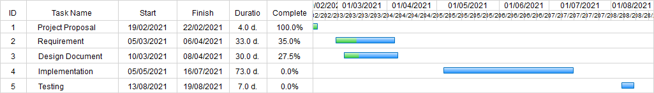

# 1.14 Team Composition

Table 1.4 Team composition

|  |  |  |  |
| --- | --- | --- | --- |
| Name | ID Number | Email Address | Responsibility |
| Helen Abay | A/ur5176/09 | helenabay980@gmail.com | Requirement gathering, Documentation, Designing, Implementation |
| Samiya Sultan | A/ur4958/09 | sultansamiyah1@gmail.com | Requirement gathering, Documentation, Designing, Implementation |
| Tsion Belachew | A/ur4955/09 | zionbelachew@gmail.com | Requirement gathering, Documentation, Designing, Implementation, programming |
| Tsion Meride | A/ur4884/09 | tsionmered@gmail.com | Coordinating, Requirement gathering, Documentation, Designing, Implementation |
| Yerosan Birhanu | A/ur4254/09 | yerobr21@gmail.com | Team leader, Requirement gathering, Documentation, Designing, programming, Implementation |

# CHAPTER 2

# 2. Description of existing system

## 2.1 Overview

Now a day’s, the events such as festivals, wedding, conferences, Seminars and others have become a core part of life which has resulted in event planning and management company to rise. With the customers and events increasing at larger rate, it is difficult to manage using traditional system using spreadsheets, traditional data storage methods and more. In order to overcome the drawbacks of traditional event coordinating system, with the help of recent technology, the distance between customer and coordinating team has reduced with the Web access.

In the present scenario, existing system has many drawbacks which make it inefficient to carry on with it. The past working system of the referred company is manual. It is difficult to maintain all details of events and users. The execution of the event sometimes delays due to unmanaged system. As far as quality is concerned it is ok but not as good when handled using computerized system. Now the inefficiency of the existing system can be stated as it is manually handled system and time consuming. In the traditional event management system data security is not assured and also it is difficult to maintain records in long run, So Large number of manpower is required.

# 2.2 Description of existing system

The existing system has many drawbacks which make it inefficient to carry on with it. There are two existing systems and the first one is manual event management system, it is difficult to maintain all details of events, customers and the services. In this system, almost all activities are done manually, which time is consuming. As far as quality is concerned it is ok but not good. This manual system does not provide the right information at the right time, data security is not assured, time consuming process and also large number of man power required.

The second system is online event management system, manual event management system replaced by online event management system software project that serves the functionality of an event manager. The system allows only registered users to login and new users are allowed to register on the application. This is proposed to be a web application. The project provides most of the basic functionality require for an event. It allows the user to select from a list of event types. Once the user enters an event type e.g. (marriage, birthday, conference etc.), the system then allows the user to select the date and time of event, place and the event equipment’s. All this data is logged in the database and the user is given a receipt number for his booking. This data is then sent to the administrator (website owner) and they interact with the client as per his requirement and his contact data stored in the database.

## **2.3 Major Function of the Current System**

In order to assess the functions of existing system in event planning and management in Ethiopia and abroad, we have tried to classify the existing system into two major categories based on their implementation approach. These categories are:

### 2.3.1 The manual event management system

In this category of event planning and management systems the company (i.e. event organizers) does almost all event management activities involved in planning, organizing and executing the event manually or using office packages(like spreadsheet and related software) and they handle every event independently without a sophisticated computer application designed for the service. The major functions of this system are:

Planning events

Event organizers have to plan many different things: the schedule, payouts, seating charts, and more. It’s going to be difficult to organize, as they will need to bring a lot of information together.

Registration for an event

Many event organizers use Google forms for registration form to record details about attendees and use combination of excel for contact lists, which are not specifically designed for events. Ticketing and payment are held during registration. Some events registration and ticketing may take place at the day of the event.

Event Promotion

Events are promoted mostly using print mediums (i.e. flyers) or call potential attendees directly.Event planners had to use lots of separate tools: spreadsheets for recording data, different types of forms for registration, because these software’s are not specifically designed for events and are not mutually linked, there are a lot of restrictions.

### 2.3.2 The event management software

This system has upgraded the system of event management and makes it easy to plan and value events. Major functions of these systems are

* Event management: - contains functionalities related to creating and managing events. It allows event planners to see all their events, create and edit new events by providing essential tools such as calendars and check lists.
* Event promotion: - can promote events on popular social networks.
* Registration for an event: - this system allows online registration. Properly maintained list makes it easy to monitor registered people.
* Booking: - allows online booking which is easy and time saving.
* Complete and customize reports: - easily edit reports and files online.

These are the major functions which are common for most of event management software.

Here are examples of event management software

Eventbrite

Eventbrite is an end-to-end event management software solution that covers the entire event lifecycle. From planning to event to post-event, the solution features tools to streamline and automate processes like registration, badge printing and reporting. It is also easy to promote your event utilizing the software’s integrated social marketing and Facebook promotion. Key features include group registration, reserved seating, fundraising, online payments and audience polling. (www.financesonline.com/event-management-software-analysis-features-pricing-type-benfits/)

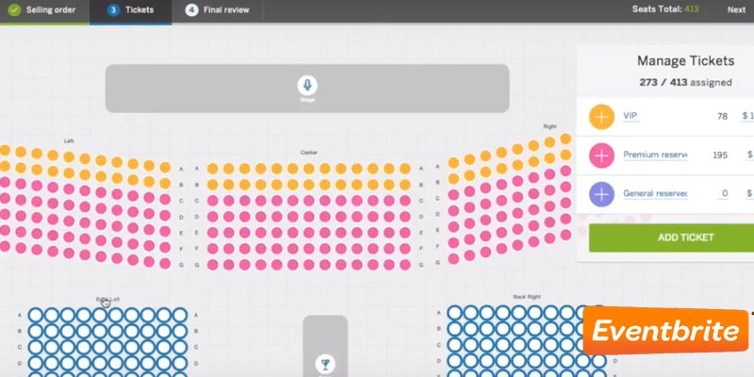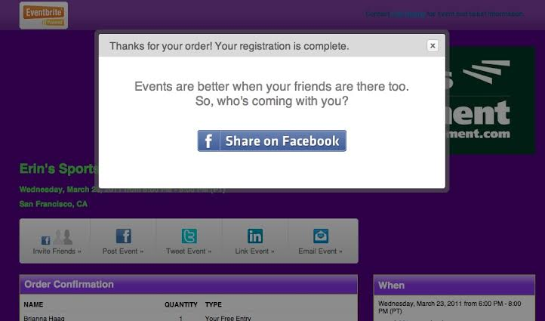

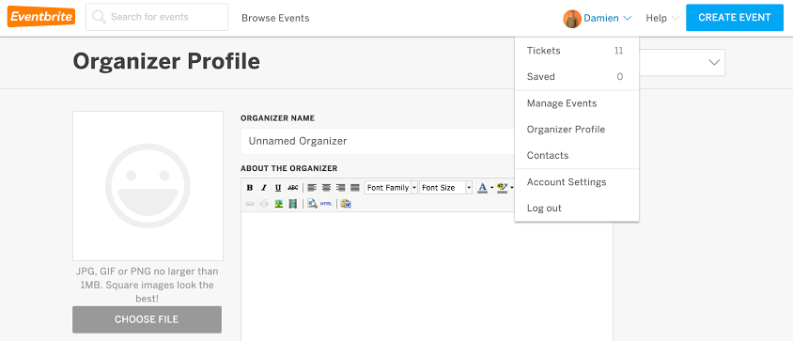

Cvent

Cvent is one of the most comprehensive event management solutions; it features tools for targeted email marketing, mainly a centralized guest list database that can be sorted by different metrics. Likewise, Cvent makes badge printing and on-site check-ins faster and smoother using consolidated data culled from online registration.

Key features include event registration, payment processing, budget management, on-site tools and mobile payments. (www.financesonline.com/event-management-software-analysis-features-pricing-type-benfits/)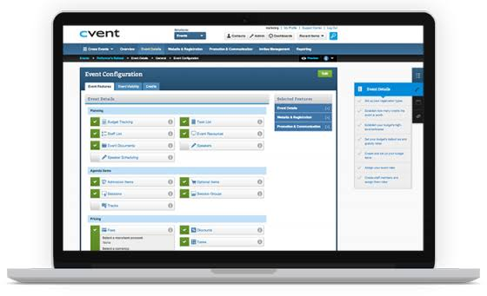

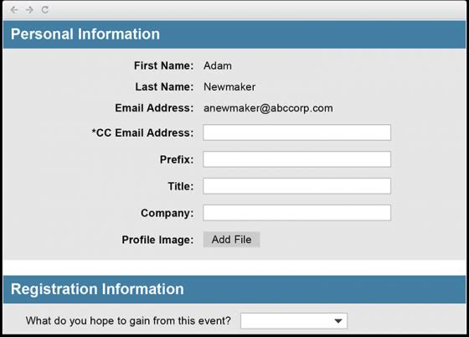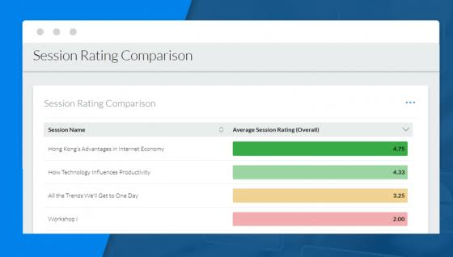

## 2.4 Users of current system

* Event planners
* Event coordinator
* Event manager
* Attendees
* Sponsors

## 2.5 Drawbacks of existing system

### 2.5.1 Manual event organizing system

* Expensive media promotion
* Not organized, Scattered data and poor data integration
* Decentralized and inconsistent communication
* Registration and Booking are available in certain time and place
* Lots of paper work which are time consuming and uneconomical which will need manual processing
* Records are difficult to store in manual system
* No updating abilities
* Finding information and keep detail secured

### 2.5.2 Event management spread sheet

* Time consuming to set up and maintain
* Designed for managing financial data, not event data
* They are susceptible to mistake and fraud
* Decentralized data
* They don’t adapt well to changing business needs
* They were built for collaboration
* They make it difficult to compile and consolidate information

### 2.5.3 Event management software’s

* Price which is expensive
* Lack of design options
* Support channels
* Negotiation are very hard with vendors
* Mature systems are less flexible

### 2.5.4 Virtual event management system

* No face to face interaction
* No afterhours networking opportunity
* Harder to hold Attendees Attention
* Networking and interaction seem limited
* Online events don’t create a revenue stream like in person event do
* Attendees have a short attention span for online event
* Online event have a higher rate of registrations

# Chapter 3

# 3. Proposed System

## **3.1 Overview**

The proposed system is a web-based system which can facilitate the services and transaction activities among event organizer, event owner and audiences in any events organized throughout the nation. The proposed system will differentiate users/clients based on the assigned privileged to access the system and allow services to them based on it. The system has three main users; each user has an access right for certain section of the proposed system and does tasks based on the predefined access rights.

This chapter is mainly focusing on requirement specification and analysis for the proposed system (i.e., an online event organization platform for Ethiopia). The chapter begins with stating functional and non-functional requirements of the proposed system. Next to that different scenarios are written to justify how the problems in the existing system shall be addressed in the proposed system. In section 3.4 of this chapter, we write solutions and draw models for the proposed system using an object-oriented modeling technique (i.e., UML). And final section of this chapter includes use-case diagram, activity and sequence diagram, class diagram, persistence and other modeling diagram supported by UML.

## **3.2 Functional requirements**

The first functional requirement is the registration of event organizer, event owner and users in the event coordinating platform so that the organizer creates the event and makes different posts about the event that they have created, this enables the viewers to see information’s about the upcoming events, to make choices and participate according to their preferences. But to participate in an event, first they need to make registration. The system allows event organizer to register (create event) and also allow attendee to register for an event.

The system also enables event owners to register and communicate with event organizers. The Event owners look for event organizers profile and select the one they think best for organizing their event by crosschecking their past work and experience they have. And it enables event owner to request the organizer and negotiate through the system.

Another functionality of a system is that it enables the event organizers to modify the events information whenever changes made regarding with the events schedule, the place where the event takes place…etc. The event organizer edits and reposts it in order to notify the attendees and other users of the system to make them aware about the changes. Notification is another functionality of the system so event organizers updates will appear in this section such as posts related with the modifications (canceled events, edited posts and so on) appear in notification.

Booking of an event is the other functionality of the system. Our system enables attendees to make an online reservation. The Attendees after seeing event lists that held in the near future in the country, make a choice to participate by selecting an event that suites their interest and if they are free and available by the time and interested in it they book for it. This will be ensured when they make payment, this online payment system will be performed with yenepay payment system.

* **Rating**

The system allows event organizers to evaluate the system by its nonfunctional requirements and make rating.

* **Feed back**

The system allows attendees to give feedback about the event for event organizers.

## **3.3 Nonfunctional requirements**

* **Usability**

The system should be easy to learn and understandable for the users so for the easy understanding our system will have a user manual that tells the users how to use the system and it is user friendly.

* **Performance requirement**

The system will respond within a short period of time. But it depends on the performance of the hardware environment and internet connection speed.

* **Accessibility**

Since our system is web based system, it needs internet connection and platform to be accessible.

* **Compatibility**

The system should have to be compatible. Since our system is web based it is compatible with any operating system environment, if web browser installed in the computer and internet connection is available.

* **Security**

Authentication in the system support user name and password to authentic. And for the privacy purpose the password will be encrypted.

* **Well documented**

The document of this project is processed in well manner and uses for future reference since it contains every activity of the entire development, design and other processes.

* **Reliability**

This system is reliable. Appropriate error message will be provided to the users whenever incorrect information is inserted and handled the occurrence of that error.

* **Error Handling and Extreme conditions**

Each error that may occur in this system will be handled accordingly in order to reduce the amount of failure.

## 3.4 Scenarios

To show the interaction of users with the proposed system, the following actors will be used in representation.

* Marta will be a viewer who wants to register.
* Kidist is a user who wants to view events list and other related information’s
* John is an already registered user who want to book for an event
* Abel is a young who attended a music concert and wanted to rate the event services
* Adama university wants to select event organizer to undergo student graduation program

In all the scenarios discussed below the following initial assumptions are made:

* The viewer has a smart device (phone, tablet or PC).
* The user has an internet connection available at his/her disposal.
* The user knows the official website address of event coordinating platform which is www.ethioEvent.com.

Scenario 1: view events

Kidist browses to the homepage with the intention of knowing upcoming events. On the given menus at the homepage she selects event list menu. Then she looks for upcoming events with their full information of date, venue and type of the event. In addition to event list kidist will get brief information about the website, contact address and also service that is provided by the system.

Scenario 2: Make registration

Marta wishes to attend a music concert event. So after she browses to the homepage of event coordinating platform, Marta selects sign up button of the homepage and again selects create account button. Then Marta is presented with a new page asking her to fill in her name, phone number, email and other detail information for the registration. Then she fills the form of registration and submits if it is fully correct. But if Marta wants to register as event organizer she needs to forward license documents to the admin. Thereafter, admin checks weather Marta is legitimate to organize an event or not. If the document is validated as legal Marta receive acceptance link by her email and if the document is not accepted re-register message will be sent with reason of un acceptance.

Scenario 3: Make booking and payment

John wishes to book a ticket for the upcoming conference event. After browsing to the homepage of the proposed system, John then logs into his account. Then he come into a Booking page and fills the form. To book, he first selects the event type he wants to attend and fill all the required information correctly. Thereafter booking, the system asks him to make payment with the payment methods systems integrated with the proposed event coordinating platform. Now John is presented with a new page asking her to fill in her name, phone number, and email and a list of banking system which are partners of the proposed system. John then selects the bank he uses and a secure window is opened for her to type her bank account number and passkey. After his account and passkey is verified, a summary of her payment with all the details is presented to him. He then clicks on the agreement and she has booked his event ticket.

Scenario 4: Rate a service by attendees

Assume Abel attended a seminar event by the last day. Then he wants to rate the event he attended so at the first we browse to the website and open the home page of event coordinating platform. Then he logs into his account. Thereafter, he browses into his rating of events and rates its service between 1 to 5 stars.

Scenario 4: selecting event organizer

Assume Adama University has graduation event and is already registered to ethioEvent website as event owner. Then they want to get event organizer who can properly coordinate the event. So that they first browse to ethioEvent website and open the home page of the website then they login as event owner and view available event organizers and their past work or experience then they request the one they think best to organize their event. Finally they negotiate and fill the given form.

## 3.5 Use Case model

#### List of Actors

1. Viewer – All viewers of the system by which they view Event lists and announcement. They will create accounts to be both Event organizers and Attendees

2. Attendees – T he one which have account to access detail information like booking status, Rating and Payment history.

1. Event Organizers – They are responsible for planning event and ensuring that they run as smoothly as possible.
2. Event owner- they check the profile of event organizers and communicate with them.
3. Admin - create a unique id for users and passwords to Event organizers and Attendee.

#### 3.5.2. Use case diagram

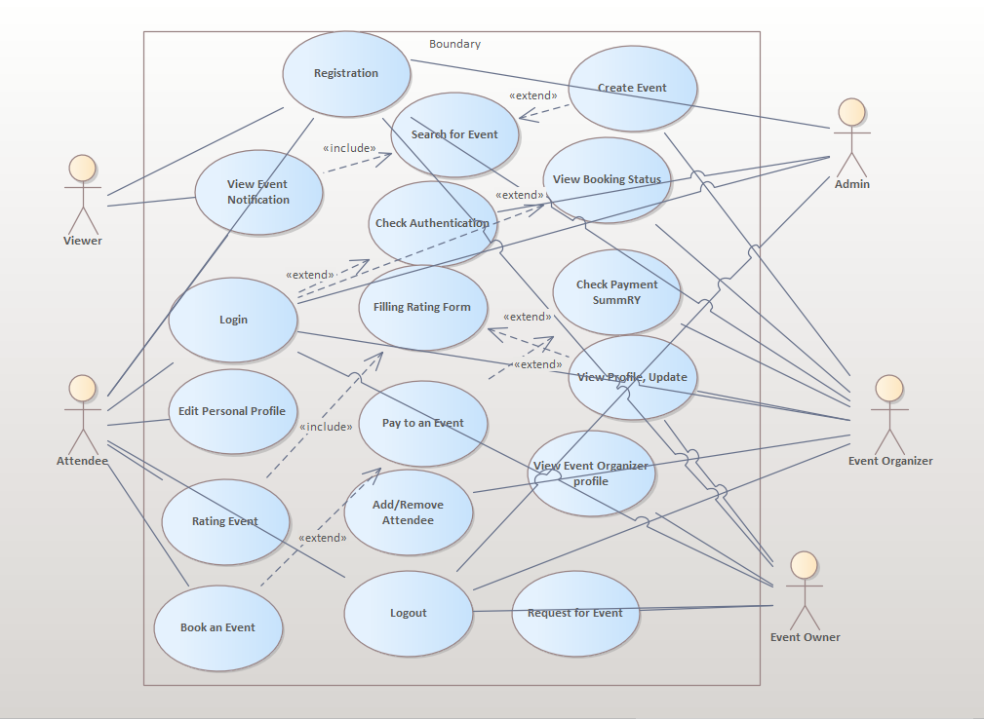

#### 3.5.3 Use case description

The following tables describe the use cases in detail.

|  |  |
| --- | --- |
| Use case ID | 1 |
| Use case name | Registration |
| Use case description | * Viewers of the system will register to create their own account to use and access some specific detail services provided by our platform |
| Participating actor | Viewer/ Attendee’s / Event Organizers |
| Pre-condition | * Internet connection have to available. * The user has to be install any web browser. * They have to navigate to [www.ethioevent.com](http://www.ethioevent.com). |
| Flow of event | * Click signup button on the home page. * Click create account. * Fill the form. * Click submit button |
| Post condition | * User can get username and password. * They can use this username and password for further uses in this system * They can fill the name and password and click Login tab * If he/she want leave the page. Click the “logout” button. |
| Alternative flow-of events | * If they entered wrong user name and password “invalid name and password” text will appear * If the users forget the password they can use the “forget password“ text and start to recover the password |

Table 3.4.3.1 use case description for Registration

|  |  |
| --- | --- |
| Use case ID | 2 |
| Use case name | View Event Notification |
| Use case description | * Users of the system will view the available event list and interact accordingly. Detail information of the events like where they are held, time, categories and other sub information’s will be listed in order to attract viewers to attend |
| Participating actor | Viewer/ Attendee’s |
| Pre-condition | * Internet connection has to available. * The user has to be install any web browser. * They have to navigate to [www.ethioevent.com](http://www.ethioevent.com). |
| Flow of event | * When the system is opened they can view many event lists * Click the event list tab and view event lists |
| Post condition | * Users view the list of the events and choose the one they want |
| Alternative flow-of events | * If they doesn’t get the desired event on the list they will use the search button * We can use the search button to type the desired name of the event by the categories or by the event organizer and check if they are available in the site |

Table 3.4.3.2.use case for View event Notification

|  |  |
| --- | --- |
| Use case ID | 3 |
| Use case name | Edit Personal Profile |
| Use case description | * This is the option in which any user of the system especially the attendees view, edit and delete the personal information’s that they fill while creating the account |
| Participating actor | Attendee’s |
| Pre-condition | * Internet connection has to available. * The user has to install any web browser. * They have to navigate to [www.ethioevent.com](http://www.ethioevent.com). * Click signup button on the home page. * Click the login and fill in the user name and password |
| Flow of event | * Click Edit Profile tab * View the recent filed personal information * Click the update tab and refill some profiles * Click the Delete tab and delete some information’s |
| Post condition | * The updated personal information’s will be saved by clicking the submit button * We can mark some profiles and delete |
| Alternative flow-of events | * Some personal profiles can’t be edited * So we can’t delete and edit all the information * If connection drop out the filled but not saved data can be lost |

Table 3.4.3.3 for use case of edit profile

|  |  |
| --- | --- |
| Use case ID | 4 |
| Use case name | Rating Event |
| Use case description | * This is the option in which any attendee of the Events will evaluate the system accordingly. They will use the form provided by the system and evaluate. |
| Participating actor | Attendee’s |
| Pre-condition | * Internet connection have to available. * The user has to be install any web browser. * They have to navigate to [www.ethioevent.com](http://www.ethioevent.com). * Click signup button on the home page. * Click the login and fill in the user name and password * Click the Rating Tab |
| Flow of event | * Select the desired Event * Fill the form of rating |
| Post condition | * After filling the form * Click the submit button * The data that is filled will be saved to the database for further analysis |
| Alternative flow-of events | * Only the attendees that attend the Events can fill the rating Form * If the form is not filled accordingly it can’t be saved to the database and sent to event organizers |

Table 3.4.3.4 for use case of Rating

|  |  |
| --- | --- |
| Use case ID | 5 |
| Use case name | Book the Event |
| Use case description | * This is the option in which any user of the system which needs to attend the event will select and reserve a seat and do the payment. |
| Participating actor | Attendee’s |
| Pre-condition | * Internet connection has to available. * The user has to be install any web browser. * They have to navigate to [www.ethioevent.com](http://www.ethioevent.com). * Click signup button on the home page. * Click the login and fill in the user name and password * Click the Tab Booking in the specific Event |
| Flow of event | * The Booking form will be opened and ready to be filled * The attendee will fill the form and select the seat they want |
| Post condition | * Click the Next page Tab and then select the payment option * Enter to the yenepay interface and fill the required information * Click the pay button |
| Alternative flow-of events | * If the Event is already booked out the Booking tab may not even work * Then use yene wallet account to pay if note create one or look for other similar options |

Table 3.4.3.5 for use case of booking an event

|  |  |
| --- | --- |
| Use case ID | 6 |
| Use case name | Create Event |
| Use case description | * This is the option by which an event organizer will create new events that will be posted on the viewer’s page |
| Participating actor | Event Organizer |
| Pre-condition | * Internet connection has to available. * The user has to install any web browser. * They have to navigate to [www.ethioevent.com](http://www.ethioevent.com). * Click signup button on the home page. * Click the login and fill in the user name and password |
| Flow of event | * Click create Event tab * Edit the event name, type, description, accommodation, and detail information |
| Post condition | * Click the post Event * Then the Event will be posted on the user site holding event information’s |
| Alternative flow-of events | * If the event organizers aren’t registered they can’t create event * If there is no internet connection they can’t create event * If the form is not filled correctly they can’t create the event |

Table 3.4.3.6 for use case of Create event

|  |  |
| --- | --- |
| Use case ID | 7 |
| Use case name | View booking status and payment summary |
| Use case description | * This is the option in which the event organizers will view the peoples booking status and the payment summary and draw conclusion and analysis |
| Participating actor | Event Organizers |
| Pre-condition | * Internet connection has to available. * The user has to install any web browser. * They have to navigate to [www.ethioevent.com](http://www.ethioevent.com). * Click signup button on the home page. * Click the login and fill in the user name and password |
| Flow of event | * Click view booking status tab * Then view the attends which start the process of booking * Click the payment summary tab and summarized which attendees paid and are on the pending process |
| Post condition | * We can view the booking status in time slot * The system will draw the summary if needed * We view the payment summary and select the paid once for further description |
| Alternative flow-of events | * If the event organizer is not approved for this process they can’t see this summary reports |

Table 3.4.3.7 for use case of booking and payment status

|  |  |
| --- | --- |
| Use case ID | 8 |
| Use case name | Add/Remove Attendees |
| Use case description | * This is the option by which the event organizer will add and remove attendees |
| Participating actor | Event Organizers |
| Pre-condition | * Internet connection has to available. * The user has to be installing any web browser. * They have to navigate to [www.ethioevent.com](http://www.ethioevent.com). * Click signup button on the home page. * Click the login and fill in the user name and password |
| Flow of event | * Click ADD/ REMOVE attendees * View the list of attendees * Add new attendees * Remove old attendees |
| Post condition | * Save the changes after Adding and Removing attendees |
| Alternative flow-of events | * Some personal profiles can’t be edited * So we can’t delete and edit all the information * If connection drop out the updates want be saved |

Table 3.4.3.8 for use case of Adding and Removing attendees

## 3.6 Object model

#### 3.6.1 Data dictionary

The data dictionary is used to define classes in the system and the member of class  
like attribute, operation and description about the classes.

|  |  |  |  |
| --- | --- | --- | --- |
| Class | Attributes | Operation | Description |
| Event | event_id, event_name, event_type, event_description,  time, date | addEvent(), cancelEvent() updateEvent(), viewEvent() | To create, edit, update and cancel events |
| Book | attendee_id, book_id, event_id, event_name | bookEvent(), cancelEvent() | For booking and canceling event |
| Payment | payment_id, attendee_id, book_id, amount_fee | pay() | For making payment |
| Feedback | feedback_id, attendee_id, event_name, feedback, Date, Time, | giveFeedback() | The attendees give feedback using this class |
| eventSchedule | Schedule_id, event_id, event_name, Date, time, duration | createSchedule()  viewSchedule()  updateSchedule()  deleteSchedule() | To create, edit and view schedule of the events |
| Admin | admin_id, user_name, password | CreateAttendeeAccount()  CreateOrganizerAccount() | To create account for the eventorganizers and the attendee |
| user | User_id, first_name, last_name, email, phone_no, user_name, password | Register(), logIn(), logout(), selectEvent(), addEvent(), cancelEvent() updateEvent(), viewEvent(), bookEvent() ,checkBooking(), Analysis(), Pay() | Allow users to register, view events,book & pay, login, logout and give access to the event organizers to add, edit, cancel and check the booking of the events |
| eventOrganizer | user_id, Name, phone_no, email, user_name, password | Register(), logIn(), logout(), addEvent(), cancelEvent() updateEvent(), checkBooking(), Analysis() | Allow the event organizers to add, edit, cancel and check the booking of the events |
| eventOwner | user_id, Name, phone_no, email, user_name, password,home_address | Register(), login(), logout(), viewEventOrganizer(), selectEventOrganizer(), sendRequest() | Allow the event owner to register, view event organizers list, select and send request for the event organizers |
| Attendee | user_id, first_name, last_name, Age, Gender ,phone_no, email, user_name, password | Register(), logIn(), logout(), viewEvent(), selectEvent(), bookEvent(), Pay() | Allow users to register, view events,book & pay, login, logout |

Table3.5.1datadictionary

#### 3.6.2 Class diagram

The class diagram is used to describe the structure of a system by showing the system's  
classes, their attributes, operations and the relationships among objects.



Diagram 3.6.1 class diagram

## 3.7 Dynamic model

### 3.7.1 Sequence diagram

#### 3.7.1.1 Event organizers registration diagram

Sequence diagram for event organizers registration shows objects and classes involved in the event organizer registration system and the sequence of messages exchanged between the objects. The registration works first by validating the filled form and then by sending license documents to the admin which helps to identify the right professionals. If the user gets acceptance link in his/her email address the user is authorized to access the system as an organizer. Otherwise the user should again send the valid document in order to register successfully.

Diagram 3.7.1 sequence diagrams for event organizers registration



#### 3.7.1.2 Booking diagram

The diagrams show an example of objects interaction in time sequence in a booking system. It depicts the objects and classes involved in the scenario and the sequence of booking. It starts by first validating the authority of accessing the page by login account and once it is known the user is authorized one, they can fill booking form and after they fill it correctly, the system prompts the user to make payment to complete booking. Then the user makes payment by using available integrated payment method with all supported mobile banking systems.

Diagram 3.7.2 sequence diagram of booking

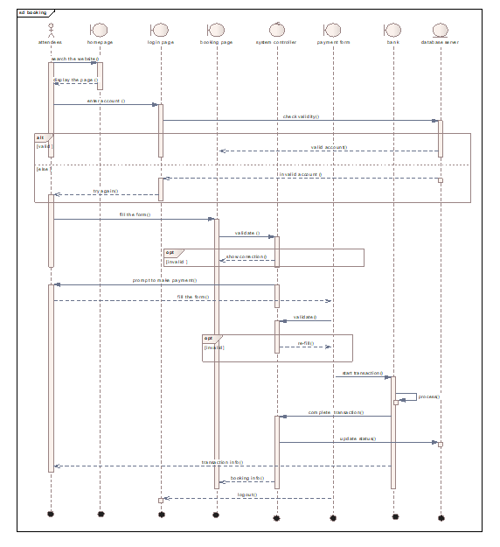

#### 3.7.1.3 Create event diagram

The diagrams show an order of object interaction in time sequence when creating an event. It works first by validating the authentication of the user by his/her login password and username and then the organizer fills the form to create an event. Then once the system controller validates the form event will be saved and status is updated.

Diagram 3.7.3 sequence diagrams for creating an event



#### 3.7.1.4 Rating diagram

The rating diagram below shows that to rate the event the user should register and attend the event. So first user login into the system and give the appropriate value of rate according to given rate form.

Diagram 3.7.4 sequence diagram for rating



### 3.7.2 Activity diagram

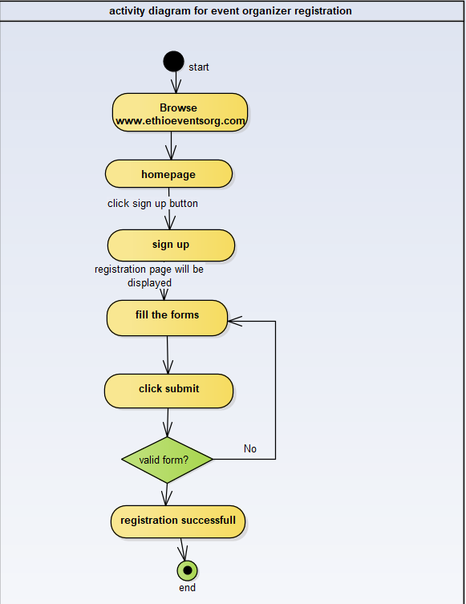

Diagram 3.7.5 activity diagram for registration

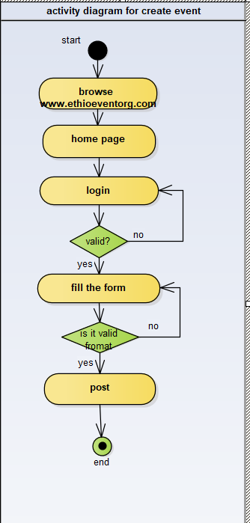

Diagram 3.7.6 activity diagram for creating event

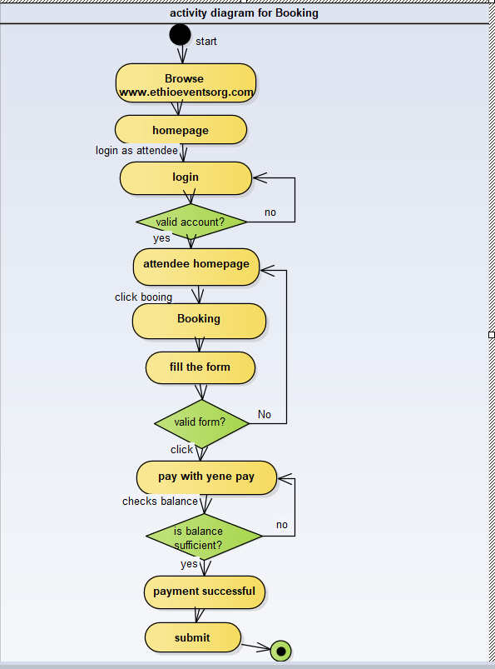

Diagram 3.7.7 activity diagram for booking

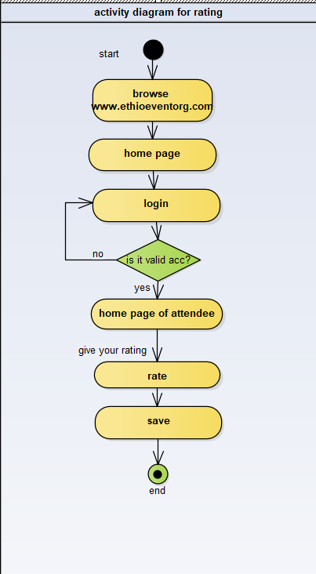

Diagram 3.7.8 activity diagram for rating

### 3.7.3 State chart diagram

#### 3.7.3.1 State diagram for booking

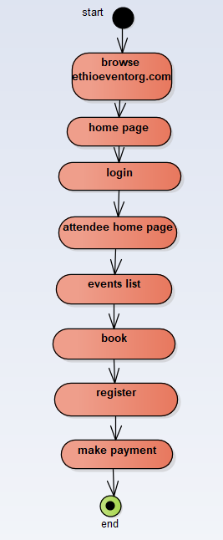

Diagram 3.7.9 state chart for booking

#### 3.7.3.2 State diagram for create event

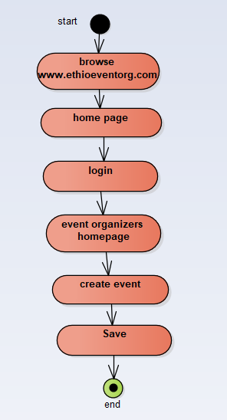

Diagram 3.8 diagram of creating an event

#### 3.7.3.3 State diagram for the registration of event organizer

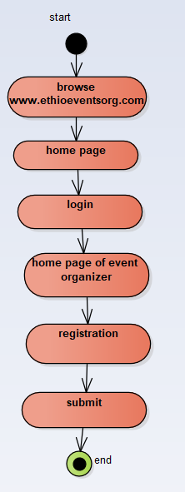

Diagram 3.8.1 state chart diagram

#### 3.7.3.4 State diagram for rating

# 

Diagram 3.8.2 state chart diagram for rating

# Chapter 4

System design

4.1. Overview of system designSystem design is the process of defining and describing the system requirements, operating environment, system and subsystem architecture, components, modules, interfaces, files and database design. This document provides the complete architectural overview of the proposed event management system through describing how its functional and nonfunctional requirements mentioned in the requirements document are transformed into more technical system design specification from which the system will be built. It specifies what is possible in this system and how it can be achieved.  
4.2. Purpose of the system design

The purpose of system design is to supplement the system architecture by providing sufficient detailed data and information about the system which is useful and necessary for implementation of the system elements.4.2.1 Design goalDesign goals describe the qualities of the system that should be considered in the development process.Performance

Response timeIn terms of response time, the proposed event management system should be able to requests from users such as searching, logging in, updating information etc. immediately. This can be accomplished with the help of load balancing algorithm.

Memory: -since our system is web application, not much memory will be requiredfor the system to run.

Dependability

**Robustness: -** the system will be able to respond for invalid user input by displaying warning messages and possible solution hints.

Availability: - the system allows access 24/7 as long as there is internet connection.

Maintainability

The proposed event management system allows new functionalities which makes it extensible. In terms of portability our system should be able run-on computers as well as mobile devices with the presence of internet. End User Criteriathe system should have simple and understandable graphical user interface. End users search for events, select events, book for events and perform other activities via recommendation based on their previous history.

# 4.3 System process

The following diagram shows the relationships of system process components



Diagram 4.1 system process diagram

# 4.4 Subsystem decomposition

A large system is usually decomposed into subsystems using both layers and partitions. Partitions vertically divide a system into several independent subsystems that provide services on the same level of abstraction. The purpose of identifying subsystems is to partition the total set of requirements into groups, each of which can be treated as a smaller, simpler problem to solve and it is useful because it can help design team members communicate with one another.

Diagram 4.2 subsystem decomposition diagrams

* **Subsystem decomposition with their purpose and class attributes**

|  |  |  |
| --- | --- | --- |
| Subsystem | Purpose | Class attributes |
| View | Allow the user to view user interface menu contents like event list and new notification without signup |  |
| Access | Used to create and manage user Account’s login operations and registration of new interested viewer, and also for the event organizer to create and update information | account, Name, Age, Gender, phone No, Email, username, password |
| Update | To update event status like booking status, to cancel add or update an event and for the user to update their profile information | Admin Id, username, password |
| Booking | To enable online ticketing and payment system | Account, bank account, phone No, Email |
| Create event | Enable event organizers to create event and post to the user | ID, Name, phoneNo, Email, username, password, eventType |
| Feedback | To give comment on the past event and rate the event accordingly | username, password |

Table 4.4.1 system decomposition and class attributes

# 4.5 Hardware/software mapping

The system will have two processes, deployed in single or separate machine that run in Parallel, namely, web server process and the database process. The database process, which Runs on MYSQL database engine, is responsible for maintaining data manipulation operations. Where us the web server process is responsible to host the web pages of the system and process Clients’ request. In case of the client side, only a browser is required to access the objects.

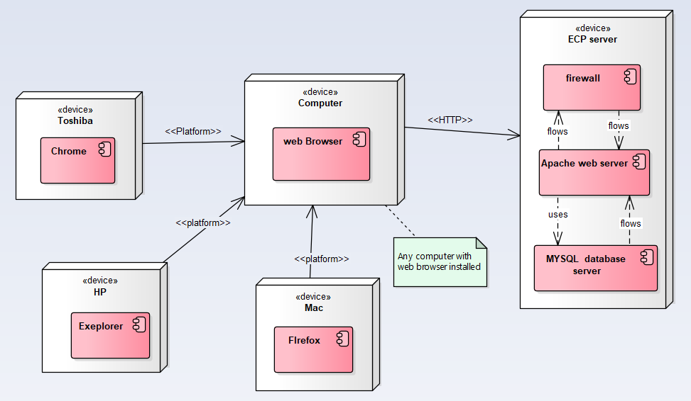

Fig : - Hardware and software mapping

# 4.6 Persistent data management

The purpose of this section is to show the mapping of the objects/classes of the system, identified during the analysis stage, into the corresponding relational database.

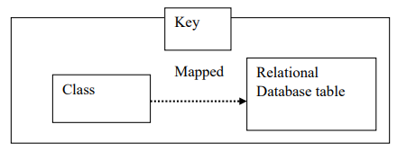

Fig. class and Database mapping

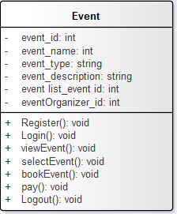 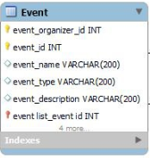

Fig:- mapping of event object

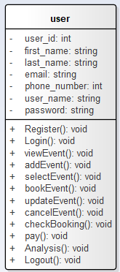 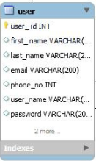

Fig:- mapping user object

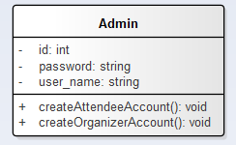 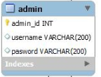

Fig:- mapping admin object

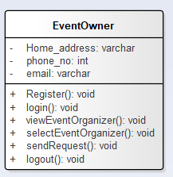 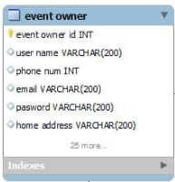

Fig:- mapping EventOwner

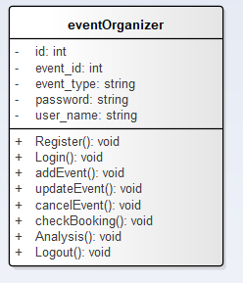 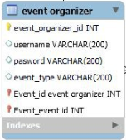

Fig:-mapping of EventOrganizer object

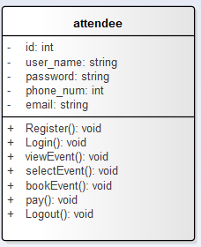 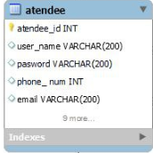

Fig:- mapping of Attendees object

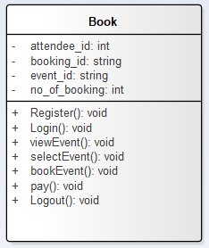 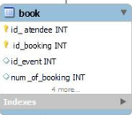

Fig:-Mapping of booking object

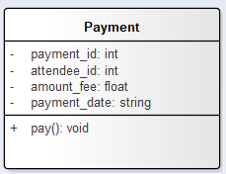 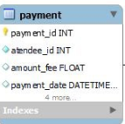

Fig . Mapping of Payment object

# 4.7 Components diagram

The following component diagram represents a group of graph of components connectedby dependency relationships. 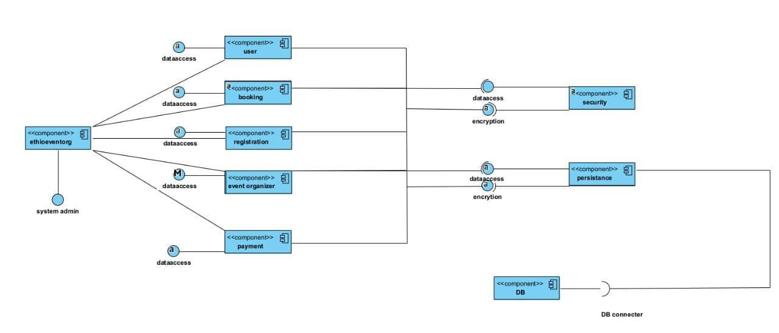

Diagram 4.9 component diagram

# 4.8 Database design

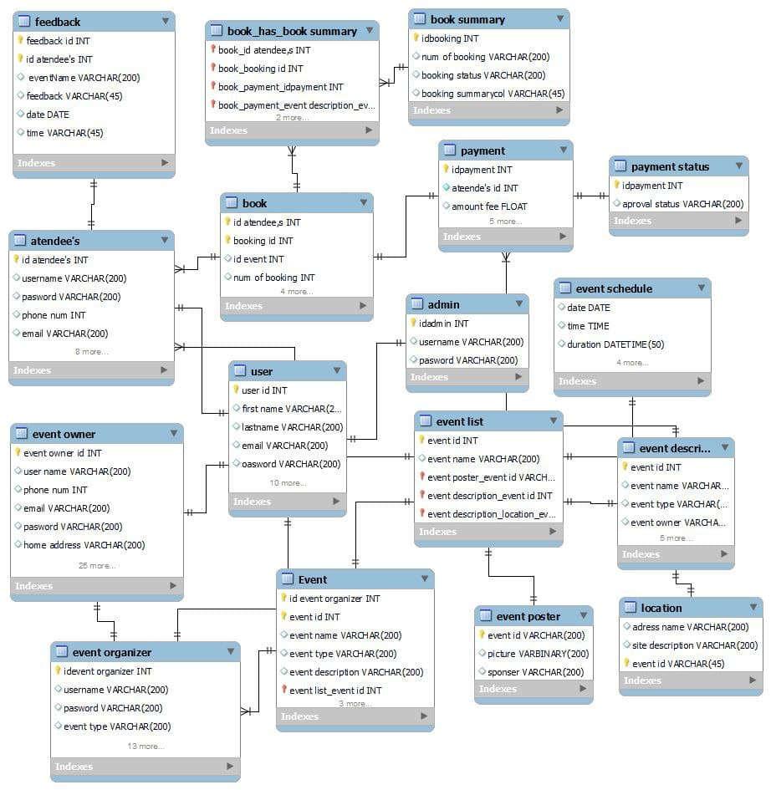

Diagram 4.10 database design

# 4.9 Access Control

In this system there are different actors with different access privileges. This part shows the

Privilege each actor has.

I. System Admin: ​ Have the following privileges

* Login
* Logout
* Update Profile
* View System Data
* View User Data
* View Service provider content
* Register new service providers
* Validate Service provider
* Registration
* View system statistics

II. Service provider Admin: has the following privileges

* Login
* Logout
* ​ Update Profile
* ​ Create Event
* Edit Event
* Delete Event
* Cancel reservation
* View Booked Event
* Cancel Booked Event
* ​ View Service Provider Information
* View Payment History
* view the attendee list
* view feedbacks summary
* Post Pictures

III. ​Registered attendee has the following privileges

* Login
* Logout
* ​ Update Profile
* View Event description and contents
* Book Event
* Cancel Booking
* Pay for the event
* Rate the Event

Iv. Viewer:

* Sign up
* View Event Information and content

# 4.10 User interface

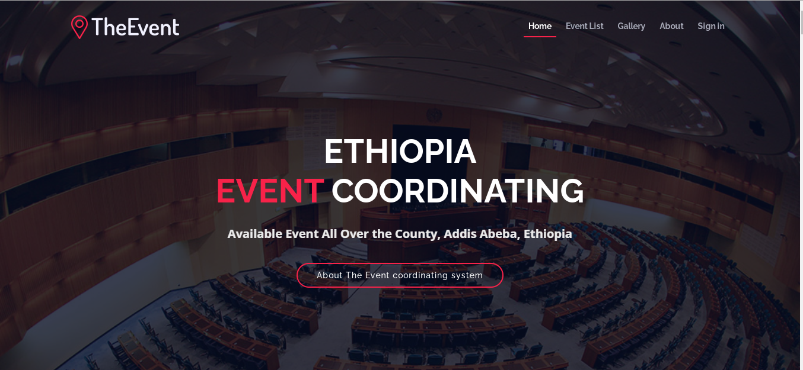

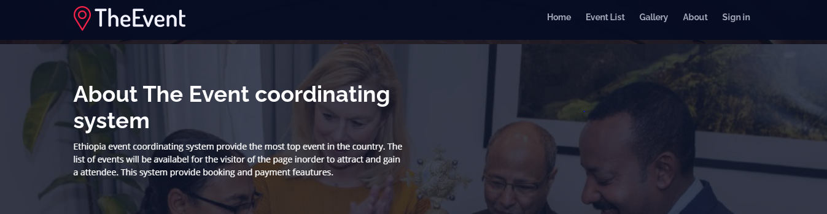

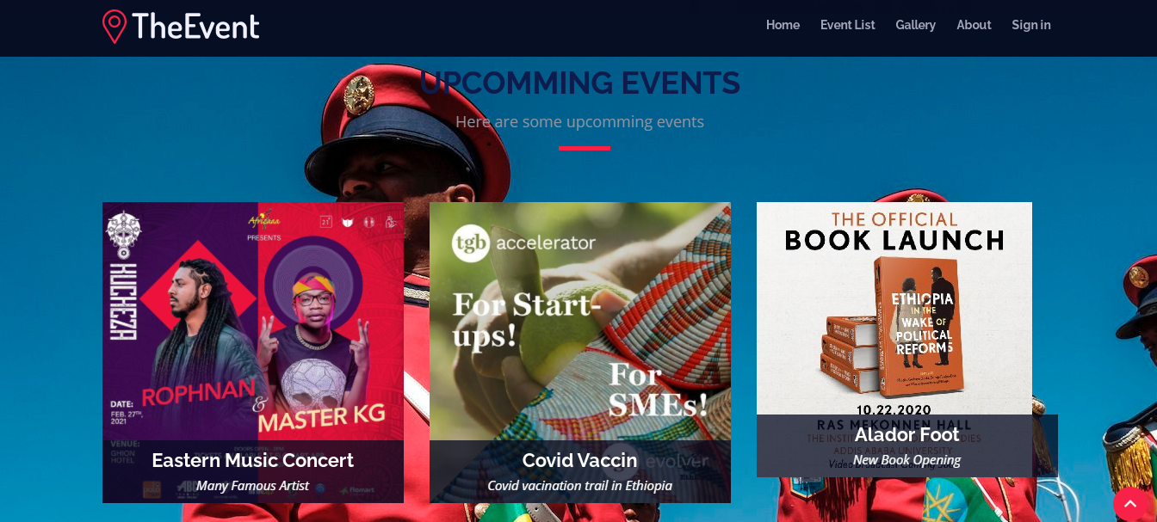



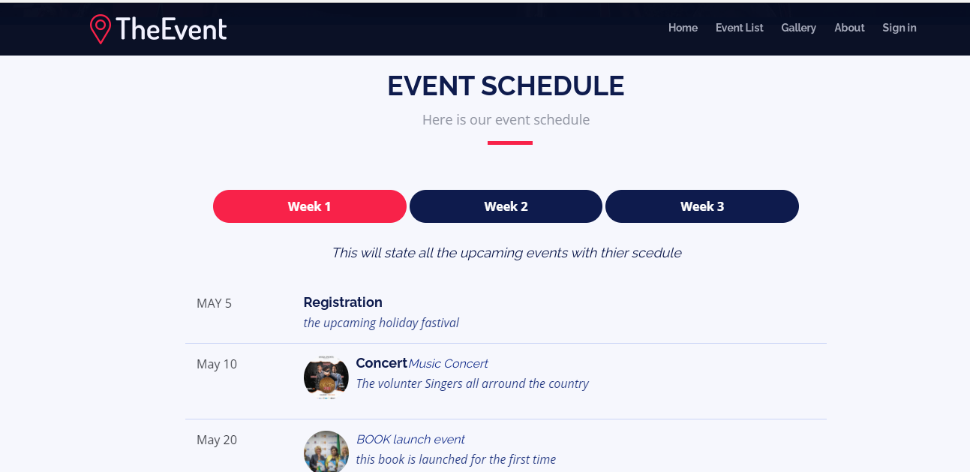

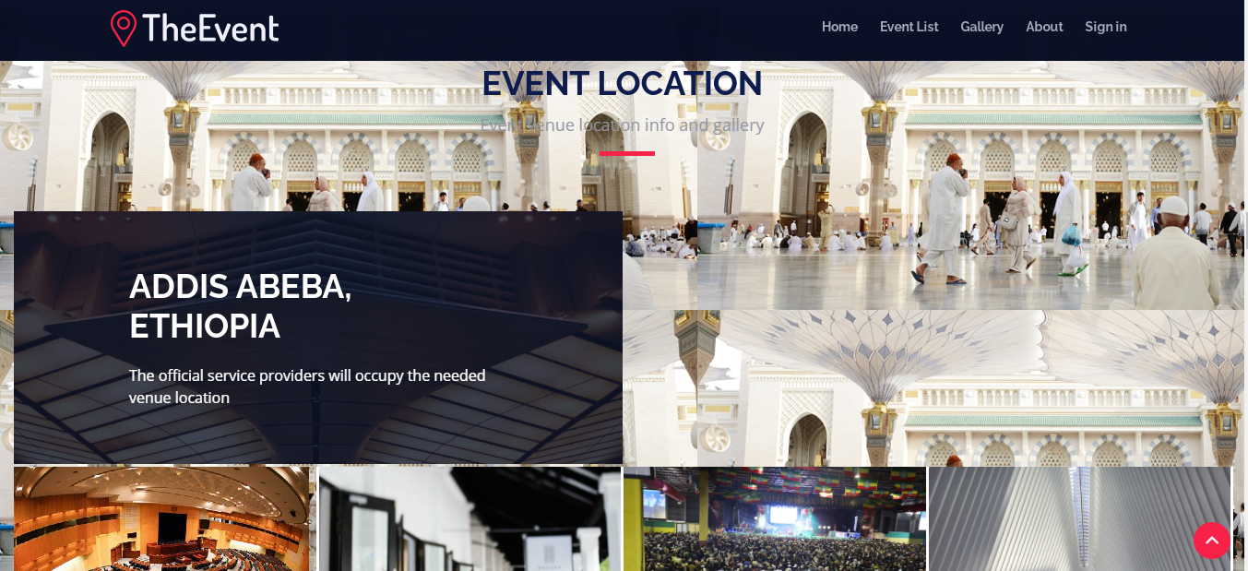

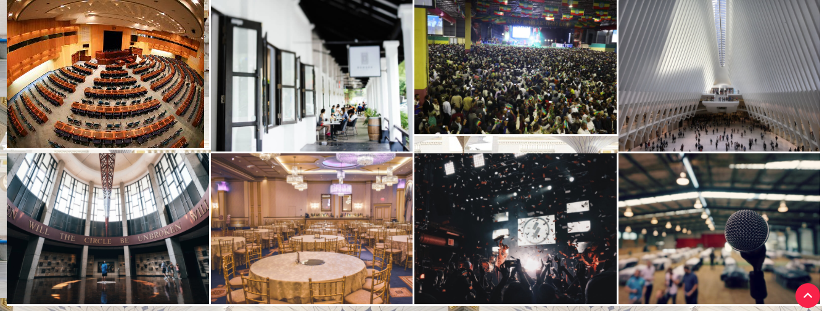

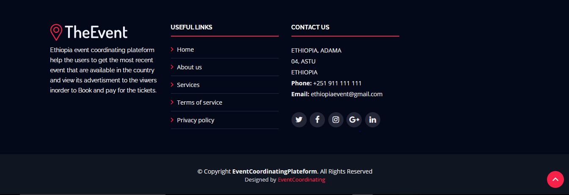

# Chapter 5

Implementation

5.1. Overview  
Implementation is the process where plans and strategies are turned into actions in order to accomplish objectives and goals. It is the development of a deliverables of the system based on the functional and nonfunctional requirements of the project. The main goal of the implementation is developing the functional requirements of the system.

# 5.2. Coding standard

Different modules specified in the design document are coded in the Coding phase according to the module specification. The main goal of the coding phase is to code from the design document prepared after the design phase through a high-level language and then to unit tests this code.

Good software development organizations want their programmers to maintain to some well-defined and standard style of coding called coding standards. They usually make their own coding standards and guidelines depending on what suits their organization best and based on the types of software they develop. It is very important for the programmers to maintain the coding standards otherwise the code will be rejected during code review.

**Purpose of Having Coding Standards:**

* A coding standard gives a uniform appearance to the codes written by different engineers.
* It improves readability, and maintainability of the code and it reduces complexity also.
* It helps in code reuse and helps to detect error easily.
* It promotes sound programming practices and increases efficiency of the programmers.

Some of the coding standards are given below:

1. **Limited use of global:**  
   These rules talk about which types of data that can be declared global and the data that can’t be.
2. **Standard headers for different modules:**  
   For better understanding and maintenance of the code, the header of different modules should follow some standard format and information. The header format must contain below things that is being used in various companies:
   * Name of the module
   * Date of module creation
   * Author of the module
   * Modification history
   * Synopsis of the module about what the module does
   * Different functions supported in the module along with their input output parameters
   * Global variables accessed or modified by the module
3. **Naming conventions for local variables, global variables, constants and functions:**  
   Some of the naming conventions are given below:
   * Meaningful and understandable variables name help anyone to understand the reason of using it.
   * Variable names and function names, should be named using underscore to separate each word and should be using small letter (e.g., localData, local_data) whereas Global variables names should start with a capital letter (e.g., GlobalData). Constant names should be formed using capital letters only (e.g., CONSDATA).
   * It is better to avoid the use of digits in variable names.
   * The names of the function should be written in camel case starting with small letters.
   * The name of the function must describe the reason of using the function clearly and briefly.
4. **Indentation:**  
   Proper indentation is very important to increase the readability of the code. For making the code readable, programmers should use White spaces properly. Some of the spacing conventions are given below:
   * There must be a space after giving a comma between two function arguments.
   * Each nested block should be properly indented and spaced.
   * Proper Indentation should be there at the beginning and at the end of each block in the program.
   * All braces should start from a new line and the code following the end of braces also start from a new line.
5. **Error return values and exception handling conventions:**  
   All functions that encountering an error condition should either return a 0 or 1 for simplifying the debugging.
6. **Avoid using a coding style that is too difficult to understand:**  
   Code should be easily understandable. The complex code makes maintenance and debugging difficult and expensive.
7. **Avoid using an identifier for multiple purposes:**  
   Each variable should be given a descriptive and meaningful name indicating the reason behind using it. This is not possible if an identifier is used for multiple purposes and thus it can lead to confusion to the reader. Moreover, it leads to more difficulty during future enhancements.
8. **Code should be well documented:**  
   The code should be properly commented for understanding easily. Comments regarding the statements increase the understandability of the code.
9. **Length of functions should not be very large:**  
   Lengthy functions are very difficult to understand. That’s why functions should be small enough to carry out small work and lengthy functions should be broken into small ones for completing small tasks.

5.3. Prototype Setup **Client side**: Our system is accessed through World Wide Web using browser installed at the client side. Client side programming has mostly to do with the user interface, with which the user interacts using computers or their smartphone.

**Components of client side**Browsers

**Server side:** is a program that runs on a server deals with generating dynamic content on a web page and interacting with the back end (i.e. database operations, user authentication, processing user input) . **Components of server side** Apache  
 MySQL

# 5.4. Implementation Detail

Implementation is divided into two parts

1. client-Side (frontend)

2. Server-Side (backend)

**Client-side**

A client is a party that requests pages from the server and displays them to the end-user. In general, a client program is a web browser. It is part of the application that runs on the user machine. Since users have different kinds of machines with different kinds of capacity client performance should be optimized as much as possible.

Client performance typically revolves around reducing the overall size of web pages. This includes the size of the files and perhaps more importantly, the number of them.

To address the above listed issues, react library which is a frontend library to build a SPA (Single Page App) is used for the web-app.

The client-side is also divided in to two

● User-frontend

● Admin-frontend

User-frontend is the part where it used by the general user, the admin-frontend is used by the service provider admin.

Other dependencies include

● React-router: - React router implements a component-based approach to the routing part.

It provides different routing components according to the needs of the application and platform

● Redox: - is an open-source JavaScript library for managing application state. It is most commonly used with libraries such as React or Angular for building user interfaces.

● Axios: - JavaScript library used to make HTTP requests that is used to communicate with server-side. Making HTTP requests to fetch or save data is one of the most common tasks a client-side JavaScript application will need to do.

● Material-UI: - open-source project that features React components that implement

Google’s Material Design that giving a consistent look across the whole site.

● React-Leaflet: - the react implementation of the open-source JavaScript library for mobile-friendly interactive maps.

**Server-side**

Server-side refers to operations that are performed by the server in a client–server relationship in a computer network and is the part of the application where the client computers request services of the server display the results the server returns.

Framework used for the backend django. Django is a high-level Python Web framework that encourages rapid development and clean, pragmatic design. It was chosen because of its speed and security.

Other dependencies include

● Django-rest framework: - framework is a powerful and flexible toolkit for building Web backend APIs.

● Django-rest-Knox: - Authentication Module for Django rest AUTH Knox provides easy to use authentication for Django REST Framework The aim is to allow for common patterns in applications that are REST based, with little extra effort; and to ensure that connections remain secure.

# 5.5. Deployment

Technologies used for the deployments are

● NGINX: - is the popular web server that powers more. But it’s more than a web server all-in-one load balancer, web server, API gateway, and reverse proxy designed for cloud‑native architectures,

● Docker: - use Docker and compose to run app directly on Linux server.

Set up Linux server and run service using Docker – compose. Create application, set it up to have all dependencies installed in Docker. Then simply run Docker –compose file on the server. It is not the best approach bet however it is the good approach. Launch product without a lot of time or effort on deployment. By taking advantage of Docker’s methodologies for shipping, testing, and deploying code quickly, you can significantly reduce the delay between writing code and running it in production

|  |  |
| --- | --- |
| Component name | Implementation detail |
| Authentication controller | Implemented using python code on Django framework to perform Authentication. It is required when the user wants to login. It checks the validity of the user login inputs. |
| Page controller | This is a route class which will direct the user to each intended pages according to the user actions. It will be implemented using python code on Django framework. |
| User view | Is the view that interact with users |
| API controller | Is a controller which uses some parameters and interact with other API based systems to fetch data. This function is controlled by the Nginx web server. |
| Payment controller | Is a controller which uses user payment input and after validation uses the API controller to get the payment token from attendee and end payment process. |
| Booking Controller | Is a controller which uses user booking input and after validation uses the API controller to get the booking token from service provider system and end booking process |
| Service Provider Registration Controller | Controls the registration of new Service provider. After the service provider admin fills the registration form this controller sends the request to a system admin for approval. After successful approval this controller sends a confirmation text to the service provider admin. |
| Load Balancer | This is the component of the Nginx web server that checks which server is able to handle user requests. |
| User search filtering controller | Controls the filtering process for the searched services provider using some filtering attribute |